**PART B – Micro–Project Report**

**Title of Micro-Project: IP Addressing and Subnetting.**

1. **Rationale:**

IP addressing is a method of assigning unique identifiers to devices on a computer network, such as the Internet. An IP address is a numerical label assigned to each device on the network, allowing them to communicate with each other using the Internet Protocol (IP).

Subnetting is the process of dividing a larger network into smaller subnetworks, each with its own range of IP addresses. This allows for more efficient use of IP addresses and can help to improve network performance and security. Subnetting involves creating a subnet mask, which determines the size and number of subnetworks that can be created within a larger network.

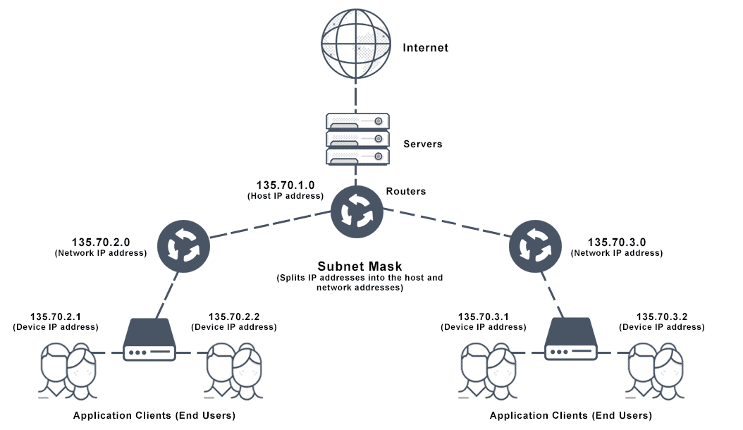

1. **Course Outcomes Addressed:**
2. Analyse the functioning of data communication and computer network.
3. Configure various networking devices.
4. Configure different TCP/IP services.

**3.0 Literature Review:**

* Books:

1. "Computer Organization and Design" by David A. Patterson and John L. Hennessy.
2. "Computer Networks" by Andrew S. Tanenbaum and David J. Wetherall.
3. "Operating System Concepts" by Abraham Silberschatz, Peter B. Galvin, and Greg Gagne.
4. "Database Systems: Design, Implementation, and Management" by Carlos Coronel, Steven Morris, and Peter Rob.
5. "Data Structures and Algorithms in Java" by Michael T. Goodrich and Roberto Tamassia.

* Websites:

1. Codecademy: https://www.codecademy.com/
2. W3Schools: https://www.w3schools.com/
3. GeeksforGeeks: https://www.geeksforgeeks.org/
4. Techopedia: https://www.techopedia.com/
5. Oracle: https://www.oracle.com/database/what-is-database/

**4.0 Actual Methodology Used:**

This addressing method divides the IP address into five separate classes based on four address bits.Here, classes A, B, C offers addresses for networks of three distinct network sizes. Class D is only used for multicast, and class E reserved exclusively for experimental purposes.

Let’s see each of the network classes in detail:

**Class A Network:** This IP address class is used when there are a large number of hosts. In a Class A type of network, the first 8 bits (also called the first octet) identify the network, and the remaining have 24 bits for the host into that network.

An example of a Class A address is 102.168.212.226. Here, “102” helps you identify the network and 168.212.226 identify the host.Class A addresses 127.0.0.0 to 127.255.255.255 cannot be used and is reserved for loopback and diagnostic functions.

**Class B Network:** In a B class IP address, the binary addresses start with 10. In this IP address, the class decimal number that can be between 128 to 191. The number 127 is reserved for loopback, which is used for internal testing on the local machine. The first 16 bits (known as two octets) help you identify the network. The other remaining 16 bits indicate the host within the network.

An example of Class B IP address is 168.212.226.204, where *168 212* identifies the network and *226.204* helps you identify the Hut network host.

**Class C Network:** Class C is a type of IP address that is used for the small network. In this class, three octets are used to indent the network. This IP ranges between 192 to 223.Mostly local area network used Class C IP address to connect with the network.

Example for a Class C IP address:192.168.178.1

**Class D Network:** Class D addresses are only used for multicasting applications. Class D is never used for regular networking operations. This class addresses the first three bits set to “1” and their fourth bit set to use for “0”. Class D addresses are 32-bit network addresses. All the values within the range are used to identify multicast groups uniquely.

**Class E Network:** Class E IP address is defined by including the starting four network address bits as 1, which allows you two to incorporate addresses from 240.0.0.0 to 255.255.255.255. However, E class is reserved, and its usage is never defined. Therefore, many network implementations discard these addresses as undefined or illegal.

Example for a Class E IP address:243.164.89.28

**5.0 Actual Resources Used:**

|  |  |  |  |  |
| --- | --- | --- | --- | --- |
| **Sr. No.** | **Name of Resource/Material** | **Specifications** | **Qty** | **Remarks** |
| **1.** | Computer | **OS:** Windows 11 (64-bit)  **Processor:** Intel i7 11th Generation  **RAM:** 16 GB | **1** |  |
| **2.** | Documentation | Microsoft word | **1** |  |
| **3.** |  |  |  |  |

**6.0 Skills Developed/learned out of this Micro – Project:**

* Time management: Managing project timelines, deadlines, and schedules require strong time management skills.
* Organization: Developing and executing a project plan requires a high level of organization and attention to detail.
* Problem-solving: Projects often involve unforeseen challenges or obstacles that require creative problem-solving skills.
* Communication: Effective communication skills are essential for project management, including communicating with stakeholders, team members, and other project participants.
* Collaboration: Projects often require collaboration with others, including team members, stakeholders, and vendors, which requires strong collaboration skills.
* Decision-making: Project managers must make many decisions throughout the project, including strategic decisions, budget decisions, and risk management decisions.
* Technical skills: Depending on the project, specific technical skills may be required, such as programming, data analysis, or web design.

**7.0 Application of this Micro-Project:**

* **Network Addressing:** IP addressing is used to assign unique addresses to devices on a network, allowing them to communicate with each other. Every device connected to the internet has a unique IP address, which is used to route data between different devices.
* **Subnetting:** Subnetting is used to divide a larger network into smaller subnetworks, which can be more efficiently managed and secured. Subnetting can help to reduce network congestion and improve network performance.
* **Routing:** Routing is the process of forwarding data packets between networks. IP addresses are used to identify the source and destination of data packets, and routing protocols use this information to determine the best path for the data to travel.
* **Security:** IP addresses are used in security systems to restrict access to certain networks or devices. Firewall rules can be set up to block or allow traffic based on the IP addresses of the source and destination devices.
* **Network Management:** IP addressing and subnetting are important for network management, as they allow administrators to easily identify and manage devices on the network. Network monitoring tools can be used to monitor network traffic and identify issues such as congestion or security threats.

**8.0 Conclusion:**

We understood the concept of IP Addressing and Subnetting.